## 



**&**



Automation test user guide

Date Version v1

IT4LIFE

15 Rue NG Route de l’Aéroport

12000 Dakar

Context **3**

Technical platform and configuration **5**

Installation and Configuration **6**

Script execution **13**

# Context

This document is a user guide to familiarize yourself with the automation test module implemented by the IT4LIFE team. It is broken down as follows:

* Technical platform and configuration
* Executing the script

|  |  |  |  |
| --- | --- | --- | --- |
| **Project :** | **Sélénium** | **Date :** | **20/09/2019** |
| **Auteurs : Babacar GUEYE– EN** | |  | |
| **Référence :** | | **Automation test user guide** | |

**RÉVISION**

|  |  |  |  |
| --- | --- | --- | --- |
| **Organisme** | **Fonction** | **Nom** | **Date / Visa** |
| **IT4LIFE** | IT Project Manager | **Babacar Gueye** |  |
| **IT4LIFE** | **Devops/Developer** | **ALioune Wele** |  |
| **IT4LIFE** | **Developer** | **ALiou Sadio** |  |

**VALIDATION**

|  |  |  |  |
| --- | --- | --- | --- |
| **Organisme** | **Fonction** | **Nom** | **Date / Visa** |
| **I-TECH** |  | Casey |  |
|  |  |  |  |
|  |  |  |  |
|  |  |  |  |

**HISTORIQUE DU DOCUMENT**

|  |  |  |  |
| --- | --- | --- | --- |
| **Version** | **Modification** | **Date** | **Auteur** |
| 0.1 | Version initiale | 20/09/2019 | EN |
|  |  |  |  |
|  |  |  |  |
|  |  |  |  |
|  |  |  |  |
|  |  |  |  |
|  |  |  |  |
|  |  |  |  |

**DIFFUSION**

|  |  |  |
| --- | --- | --- |
| **STRUCTURE** | **RÉFÉRENT** | **Mode de diffusion** |
| IT4LIFE | Babacar Gueye | Électronique |
| IT4LIFE | Aliou Wele | Electronique |
| IT4LIFE | Aliou Sadio | Electronique |
| I-TECH | Cassey | Electronique |

# Technical platform and configuration

During the entire implementation phase of the automation tool we will use our machines for development and testing. The ITECH team will be able to do the same configuration on their machines to perform tests and validate the work performed.

# Installation and Configuration

In this section we will talk about the installation and configuration of selenium webdriver on windows.

Selenium uses webdrivers to interact with browsers. There is a webdriver per browser supported and can be run under Windows as with Linux and test writing can be done in different languages (PHP, Python, Ruby,.NET, Perl and Java).

In our case we will install under windows with Chrome as webdrive and Python3 as programming language.

**Python3 Installation**

* **Download the python installer program**

1. Open your browser and access the "Downloads for Windows" section of the official python website.
2. Search for the python3 version
3. Select a link to download either "windows x86-64 executable installer" or "windows x86 executable installer"

* **Running the installation program**
  1. **Run the downloaded installation program**
  2. **Be sure to select the installation program for all users and check the "Add Python to Path" box.**
  3. **Select "Install Now" - recommended installation options**

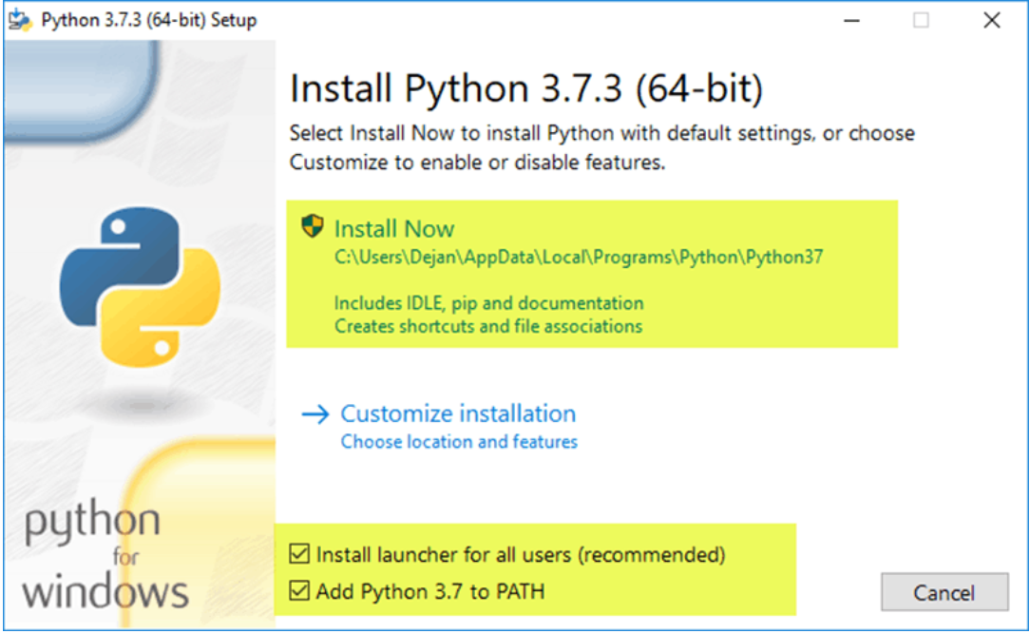

* **Check that Python has been installed under Windows**
  1. Go to the directory where Python was installed on the system
  2. Double-click on python.exe.
  3. The result should be similar to what you can see below

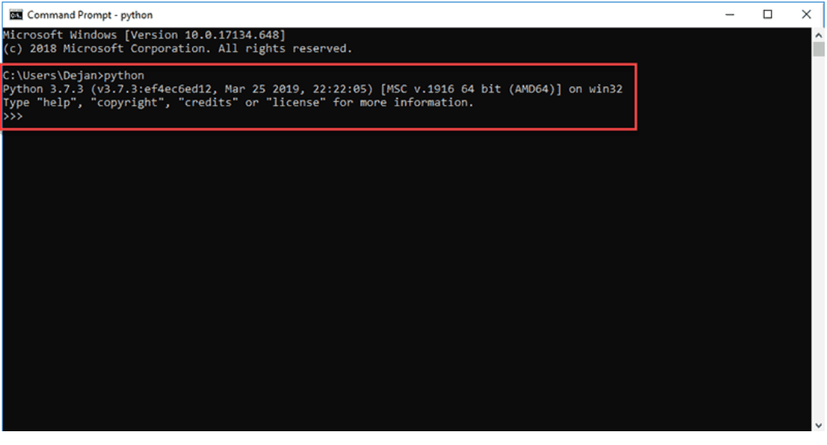

* **Check that Pip has been installed**
  1. Open the start menu and type "cmd"
  2. Select the command prompt application.
  3. Enter “pip -V” in the console. If Pip has been successfully installed, you should see the screen below:

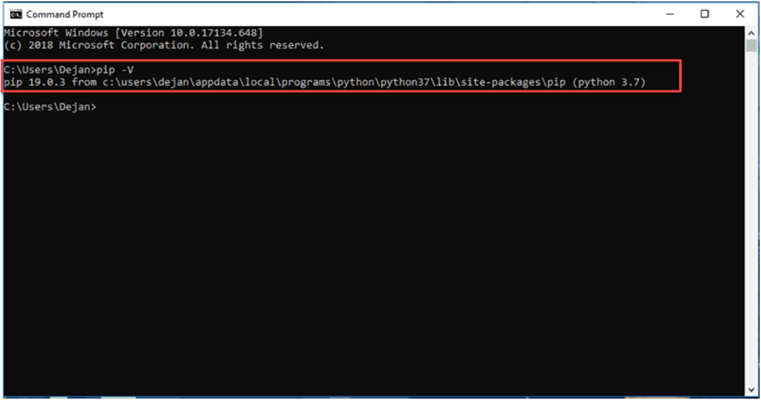

**Selenium installation**

1. Open the start menu and type "cmd"
2. Select the command prompt application
3. Enter "pip install selenium" in the console.

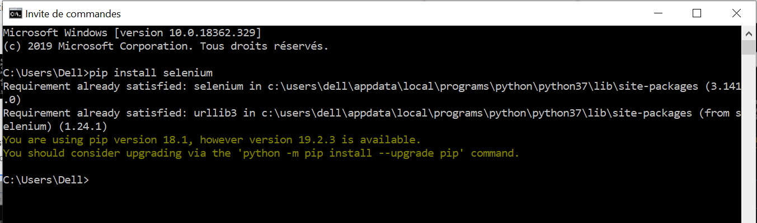

Download and Configuration of the Chrome webdriver

* **Download the Chrome webdriver**

If you are using version 78 of Chrome, please download [ChromeDriver 78.0.3904.11](https://chromedriver.storage.googleapis.com/index.html?path=78.0.3904.11/)

If you are using version 77 of Chrome, please download [ChromeDriver 77.0.3865.40](https://chromedriver.storage.googleapis.com/index.html?path=77.0.3865.40/)

If you are using version 76 of Chrome, please download [ChromeDriver 76.0.3809.126](https://chromedriver.storage.googleapis.com/index.html?path=76.0.3809.126/)

* **Configuration du webdriver**

**Téléchargement et Configuration du webdriver Chrome**

* **Téléchargement du webdriver Chrome**

Si vous utilisez la version 78 de Chrome, veuillez télécharger [ChromeDriver 78.0.3904.11](https://chromedriver.storage.googleapis.com/index.html?path=78.0.3904.11/)

Si vous utilisez la version 77 de Chrome, veuillez télécharger [ChromeDriver 77.0.3865.40](https://chromedriver.storage.googleapis.com/index.html?path=77.0.3865.40/)

Si vous utilisez la version 77 de Chrome, veuillez télécharger [ChromeDriver 76.0.3809.126](https://chromedriver.storage.googleapis.com/index.html?path=76.0.3809.126/)

* **Configuration du webdriver**

it will be necessary to add the webdriver (chromedriver) that we downloaded in the environment variables of the system.

1. In the start menu type "environment"
2. Select the "Modify system environment variables" application
3. Click on the "Environment Variable" button

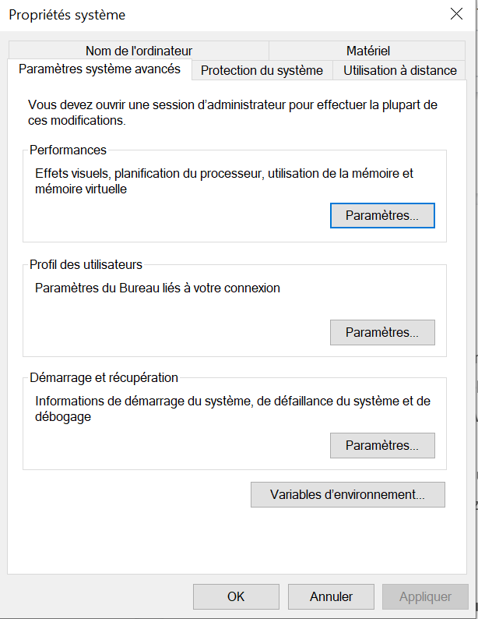

1. In the user section select the "path" line and click on the edit button

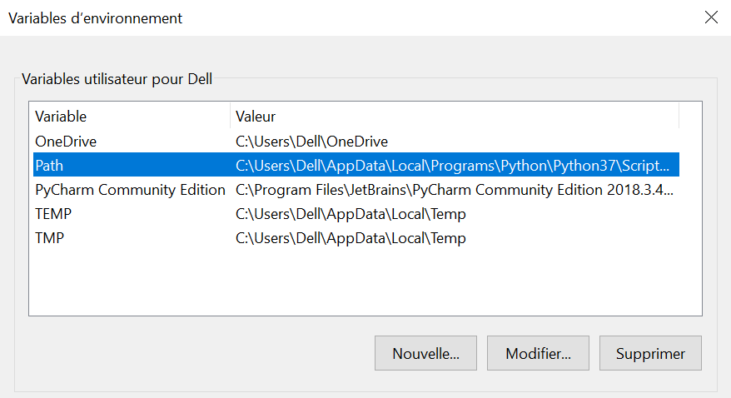

1. Click again and enter the path of the folder that contains the webdriver (chromedriver) in our case it is "C:\Users\Dell\Documents\Selenium" (Adapt according your environment/computer setup)

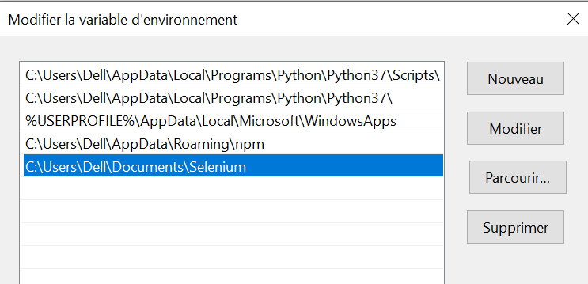

1. Save the changes and exit

To check if the configuration went well, open the command prompt and type "chromedriver" and you will have:

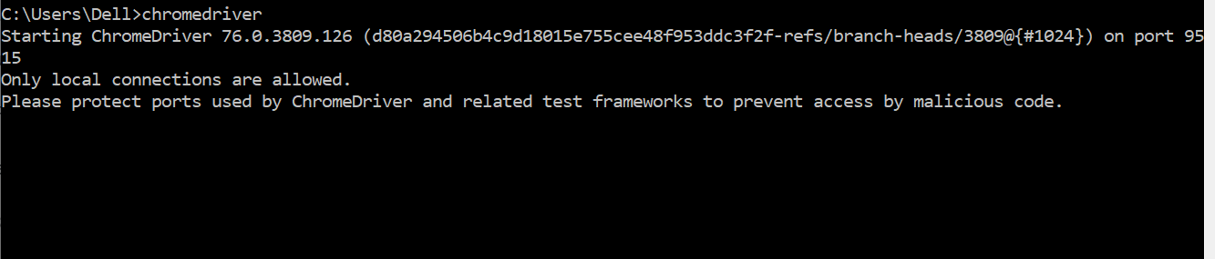

.

# Script execution

Once the settings are made, we can proceed to the execution of the script.

To launch the script you will need to execute the main.py file located in the root of the project by command prompt, IDLE or Pycharm.

* Via command prompt
  1. Open the command prompt
  2. Move the cursor to the project folder
  3. Type the command'python main.py'.

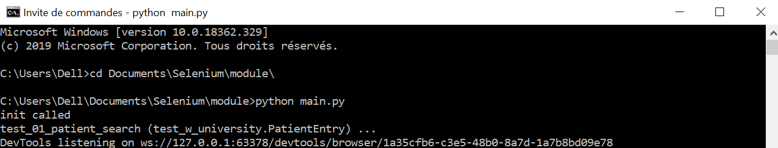

* Via IDLE

1. Type "idle" in the start menu
2. Select the application'IDLE'.
3. Select the menu “File → Open”

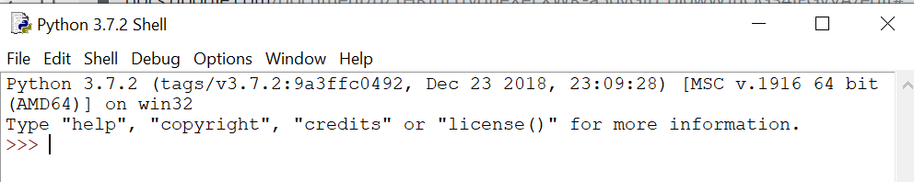

1. Move to the project folder and select the main.py file
2. Click on the menu “Run → Run Module” to execute the script

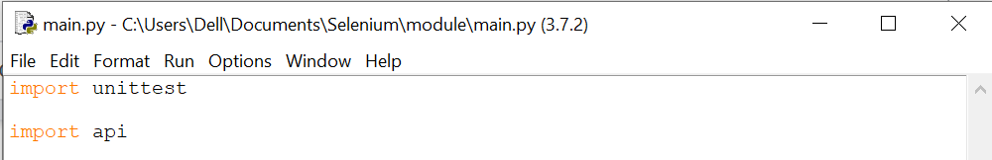

* Via Pycharm

1. Type "pycharm" in the start menu
2. Select the application 'pycharm'.
3. In 'File → Open' select the project folder
4. Double click on the main.py file
5. Click on the ‘start' button to execute the script

